**MICRO PROJECT ON**

**“Computer peripheral devices.”**

**Course: Computer peripheral hardware (CPH)**

**Corse Code: 22013**

**Academic Year: 2022-2023**

**Semester: 2 I**

**Name of group leader: Rushi Raviraj Gujarathi**

**Roll No.: 532-539**

**Enrollment No:2201410263**

**Name of Micro project Guide: Mr. S.P.Wandhare**

**All India Shri Shivaji Memorial Society Polytechnic**

**Kennedy Road , Near RTO, Pune-411001**

All India Shri Shivaji Memorial Society’s Polytechnic

Kennedy Road Near RTO, Pune-411 001

======================================

**CERTIFICATE**

Certified that this micro project report titled Computer peripheral devices is the bonafide work of Ms./Mr. Group 5 Roll no 532-539 of first year diploma in Computer Engineering for the course: CPH: Computer peripheral hardware Course code:22013 during the academic year 2022-23 , who carried out the micro project work under my supervision.

Mr.S.P.Wandhare

Name and signature subject Teacher

**Acknowledgement**

We the students of first year diploma in Computer Engineering, division C, **Group 5,** Roll no: **532-539** are very much thankful to **Mr.S.P.Wandhare** for her constant support, encouragement and guidance for completion of the micro project report entitled ‘Computer peripheral devices of the course: Computer peripheral hardware (CPH) Course code:22102 during the academic year 2022-23.

**(**533- Rushi Gujarathi)

**Roll no, Name and Signature of Group leader**

**INDEX**

|  |  |  |
| --- | --- | --- |
| **Sr. No.** | **Content** | **Page No.** |
| 1. | Micro Project Proposal | 7 – 8 |
| 2. | Rationale | 9 |
| 3. | Aims / Benefits of the Micro Project | 9 |
| 4. | Course Outcome achieved | 9 |
| 5. | Literature Review | 10 |
| 6. | Actual Methodology Followed | 10 |
| 7. | Actual Resources Used | 8 |
| 8. | Output of the Micro Projects | 11 |
| 9. | Skill Developed / Learning outcome of the Micro Project | 11 |
| 10. | Applications of the Micro Project | 12 |

**ANNEXURE I**

**Micro Project Proposal**

1. **Aims/Benefit of the Micro Project** (Minimum 30-50 Words)**:**

Aim of this micro project is to learn and understand what is peripheral devices and what are the types of this devices and what are the uses of this devices.

1. **Course Outcomes Addressed:**

**C22013.a** Identify the different types of computer systems.

**C22013.c** select processors required for relevant systems**.**

**C22013.e T**roubleshoot peripherals and network.

1. **Proposed Methodology** (Procedure that will be followed to do the micro project- in about 100-200 words)**:**
2. Finalize the topic.
3. Arrange a group meeting through google meet to distribute responsibilities.
4. Find and Collect information.
5. Arrange information and distribution of work.
6. . Draft copy of micro project report.
7. Proofread the draft in a group.
8. Review from the teacher.
9. Edit project report as per the suggestions of the teacher.
10. Proofread in a group and finalize the report.
11. Submission of the report.
12. **Action Plan:**

|  |  |  |  |  |
| --- | --- | --- | --- | --- |
| **Sr. No.** | **Detail of Activity** | **Planned Start date** | **Planned Finish Date** | **Name of Responsible Team Members** |
| **1.** | Arrange a meeting to allot work. | 15/03/2023 | 15/03/2023 | Param Jadhav, Rushi Gujarathi |
| **2.** | Find and Collect information. | 18/03/2023 | 15/03/2023 | Om jade, Vishal layer, shruti Jadhav |
| **3.** | Proofread the draft in a group. | 19/03/2023 | 19/03/2023 | All Members |
|  | | | | |
| **4.** | Proofread in a group and finalize the report | 23/03/2023 | 20/03/2023 | All Members |
| **5.** | Draft copy of micro project report | 25/03/2023 | 26/03/2023 | Shruti Jadhav |
| **6.** | PPT | 25/03/2023 | 01/04/2023 | Rushi Gujarathi |
| **7.** | Review from the teacher | 03/04/2023 | 04/04/2023 | Mansi Gunjal ,Yash Jadhav |
| **8.** | Edit project report as per the suggestions of the teacher | 05/04/2023 | 05/04/2023 | Param Jadhav |
| **9.** | Submission of the report | 15/04/2023 | 15/04/2023 | All Team members |

1. **Resource Required:**

|  |  |  |  |  |
| --- | --- | --- | --- | --- |
| **Sr. No.** | **Name of Resource/Material** | **Specification** | **Qty.** | **Remark** |
| **1.** | computer | To make index & ppt | 1 |  |
| **2.** | Google | To collect information | _ |  |
| **3.** | Word | To edit Index | _ |  |
| **4.** | YouTube | To understand the concepts and collect to information |  |  |
| **5** | Microsoft PowerPoint | To edit PPT | - |  |

**Name of Team Members with Roll Nos:**

|  |  |  |
| --- | --- | --- |
| **Roll no.** | **Name of Students** | **Work assigned** |
| **532** | Shubham Giri | Collect information |
| **533** | Rushi Gujarathi | Powerpoint presentation |
| **534** | Mansi Gunjal | Collect information |
| **535** | Vishal Iyer | Collect information |
| **536** | Om Jade | Collect information |
| **537** | Param Jadhav | Edit index and review index from Sir. |
| **538** | Sharvani Jadhav | Collect information |
| **539** | Shruti Jadhav | Collect information |
| **540** | Yash Jadhav | Collect Information |

Mr.S.P.Wandhare

Name and signature subject Teacher

**ANNEXURE - II**

**Micro Project Report**

**Computer peripheral devices.**

1. **Rationale:** (Importance of the project, in about 30 to 50 Words.)**:-**

Peripherals Devices We use our day -to -day life for making our life easy. In our life there are many uses of computer Peripherals Devices. We the help of Peripherals devices we make our life very easy. Ex, We use computer to collect, we collect data very easily.

1. **Aims/ of the Micro Project: -** Aim of this micro project is to learn

And understand what is peripheral devices and what are the types of this devices and what are the uses of this devices.

1. **Course Outcomes Achieved: -**

**C22013.a** Identify the different types of computer systems.

**C22013.c** select processors required for relevant systems**.**

**C22013.e T**roubleshoot peripherals and network.

1. **Log book: -**

|  |  |  |  |
| --- | --- | --- | --- |
| **Sr. No.** | **Date** | **Time** | **Work Done** |
| **1.** | 15/03/2023 | 04pm – 05 pm | Arranging a meeting to allot work. |
| **2.** | 17/03/2023 | 06 pm – 07 pm | Searching information. |
| **5.** | 21/03/2023 | 06 pm – 07 pm | Arranging a meeting, to review the information collected. |
| **6.** | 22/03/2023 | 06 pm – 07 pm | Arranging a meeting to finalize the information reviewed. |
| **7.** | 25/03/2023 | 06 pm – 07 pm | Preparing Draft Copy of the report. |
| **8.** | 0504/2023 | 06 pm – 07 pm | Preparing Draft Copy of the report. |
| **9.** | 15/04/2023 | 06 pm – 07 pm | Preparing PowerPoint Presentation. |
|  | | | |
|  | | | |
| **10.** | 15/04/2023 | 06 pm – 07 pm | Preparing PowerPoint Presentation. |
| **11.** | 15/04/2023 | 11 am – 12noon | Review from Teacher regarding Report. |
| **12.** | 17/04/2023 | 06 pm – 07 pm | Editing Report as per Teacher’s Suggestion. |
| **13.** | 20/04/2023 | 12 pm – 1pm | Final Submission of Report. |

1. **Literature Review: -**

The Information about the Project was researched and noted from **Google.**

The PowerPoint Presentation was prepared using **Microsoft Office 2010 PowerPoint.**

Images for the Report were made/taken using: **Paint and Camera Apps.**

Other reference information was collected using **Wikipedia.**

Information about applications: **google**

Information about Peripherals Devices: **Google**

Concept about Peripherals Devices learn from: **YouTube.**

1. **Outputs of the Micro project** (Presentation of data, findings, drawing etc.)**:-**

**Peripherals:** The term peripherals refer to all hardware devices that are attached to your computer and are controlled by your computer System.

Input devices: An input device allows data such as text, images, video or sound to be entered into a computer system. Keyboard - The most common input device used for entering text. Includes keys for word processing and data inputting, and for performing specific functions.

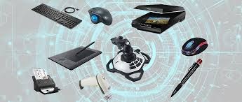

**Keyboard:**

Keyboard is the most common and very popular input device which helps to input data to the computer.

The layout of the keyboard is like that of traditional typewriter, although there are some additional keys provided for performing additional functions.

Keyboards are of two sizes 84 keys or 101/102 keys, but now keyboards with 104 keys or 108 keys are also available for Windows and Internet.

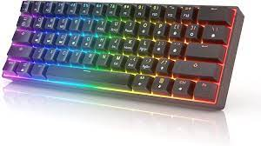

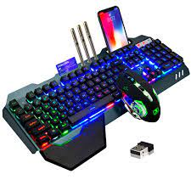

**Joystick:**

* Joystick is also a pointing device, which is used to move the cursor position on a monitor screen. It is a stick having a spherical ball at its both lower and upper ends. The lower spherical ball moves in a socket. The joystick can be moved in all four directions.
* The function of the joystick is similar to that of a mouse. It is mainly used in Computer Aided Designing (CAD) and playing computer games.

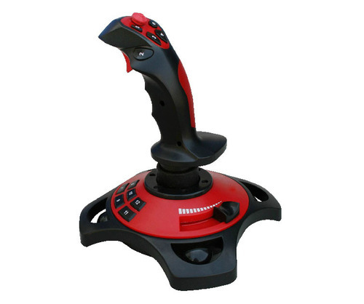

**Light Pen**: Light pen is a pointing device similar to a pen. It is used to select a displayed menu item or draw pictures on the monitor screen. It consists of a photocell and an optical system placed in a small tube.

* When the tip of a light pen is moved over the monitor screen and the pen button is pressed, its photocell sensing element detects the screen location and sends the corresponding signal to the CPU.
* 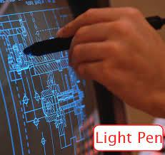Light pen is a pointing device similar to a pen. It is used to select a displayed menu item or draw pictures on the monitor screen. It consists of a photocell and an optical system placed in a small tube.

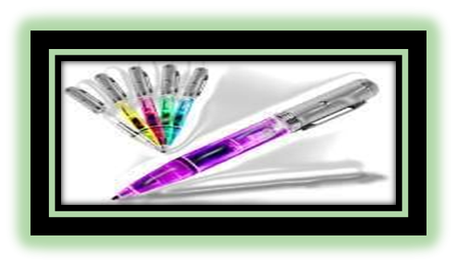

**Scanner:**

Scanner is an input device, which works more like a photocopy machine. It is used when some information is available on paper and it is to be transferred to the hard disk of the computer for further manipulation.

Scanner captures images from the source which are then converted into a digital form that can be stored on the disk. These images can be edited before they are printed.

**Microphone:**

Microphone is an input device to input sound that is then stored in a digital form.

The microphone is used for various applications such as adding sound to a multimedia presentation or for mixing music.

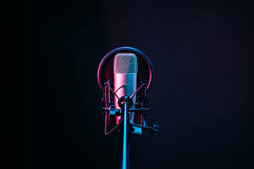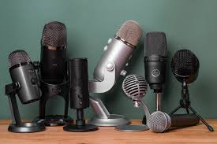

**Bar Code Readers:** Bar Code Reader is a device used for reading bar coded data (data in the form of light and dark lines).

Bar coded data is generally used in labelling goods, numbering the books, etc. It may be a handheld scanner or may be embedded in a stationary scanner.

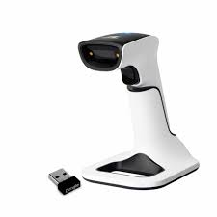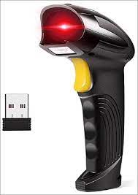

**Optical Mark Reader (OMR)**: OMR is a special type of optical scanner used to recognize the type of mark made by pen or pencil. It is used where one out of a few alternatives is to be selected and marked.

* It is specially used for checking the answer sheets of examinations having multiple choice questions

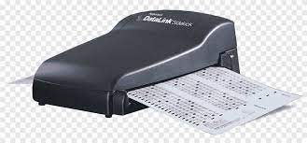

**Output devices:**

A peripheral device that helps a computer system to reproduce input data or instructions is called an output unit of a computer. After a user enters the raw data as input, the processor receives that information and processes the data. Then, the computer system distributes the processed data to the users through various output units. Output devices transform computer data into a human-understandable form. This tutorial is an easy way to learn more basic ideas on the different types of output devices and there. utility

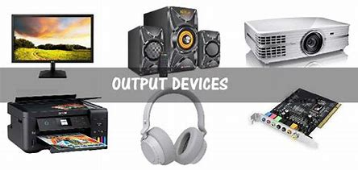

**Monitor:**

* A monitor is a piece of computer hardware that displays the video and graphics information generated by a connected computer through the computer's video card
* 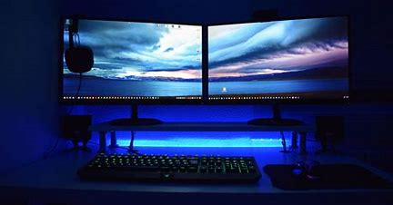Monitors are similar to TVs, but usually display information at a much higher resolution. Also, unlike televisions, monitors typically sit atop a desk rather than being mounted on a wall. A monitor is sometimes referred to as a screen, display, video display, video display terminal, video display unit, or video screen.

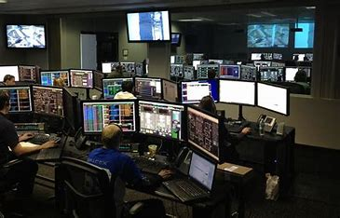

**Speakers**: A speaker is the user who is giving vocal commands to a software program using voice recognition.

A computer speaker is an output hardware device that connects to a computer to generate sound. The signal used to produce the sound that comes from a computer speaker is created by the computer's sound card

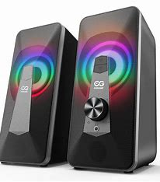

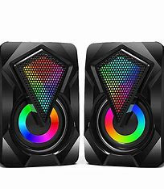

**Projector:** A projector is an output device that takes images generated by a computer or Blu-ray player and reproduce them by projection onto a screen, wall, or another surface.

In most cases, the surface projected onto is large, flat, and lightly colored. For example, you could use a projector to show a presentation on a large screen so that everyone in the room can see it.

Projectors can produce either still (slides) or moving images (videos). A projector is often about the size of a toaster and weighs only a few pounds.

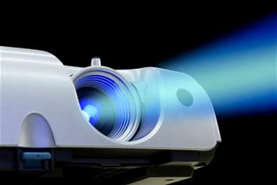

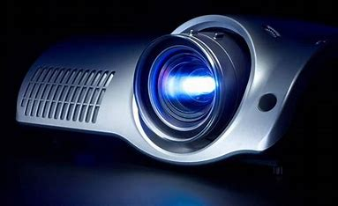

**Plotter:** A plotter is a computer hardware device much like a printer that is used for printing vector graphics.

* Instead of toner, plotters use a pen, pencil, marker, or another writing tool to draw multiple, continuous lines on paper rather than multiple dots, like a traditional printer

.

* Plotters produce a hard copy of schematics and other similar applications.

Though once widely used for computer-aided design, these devices were more or less phased out by wide-format printers

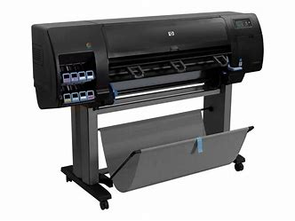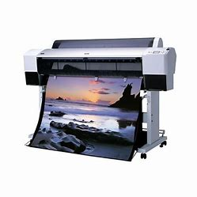

*THANK YOU FOR VIEWING OUR  
 PRESENTATION.  
WE HOPE YOU HAD A GOOD TIME*

Submitted by Group 5 Roll no (532-539)

1. **Skill developed / Learning outcome of the Micro-Project: -**
2. Communication skills.
3. Time management.
4. Working in a team.
5. Following ethics.
6. Stress management.
7. Psychomotor skills such as making model/chart and its demonstration.
8. Presentation skills.
9. Upgrading knowledge of physics through activity.

**MICRO PROJECT ON:**

**‘Computer peripheral devices.’**

For AICTE Diploma courses Wef: 2022-2023

AISSMS’s Polytechnic, Pune 1(0141)

**Annexure IV:** **Rubrics Used for Evaluation of a Micro Project in Computer peripheral devices.’**

**(22103)**

|  |  |  |  |  |  |
| --- | --- | --- | --- | --- | --- |
| **Sr. No** | **Characteristic to be assessed** | **Indicators for different Levels of Performance (Evaluation Scale: 1-10)** | | | |
| **Poor (1-3)** | **Average (4-5)** | **Good (6-8)** | **Excellent (9-10)** |
| **1** | **Relevance to the course** | Related to vary few LOs | Related to some Los | Addressed at-least one CO | Addressed more than one CO |
| **2** | **Literature review/ information collected** | Not more than two sources (Primary and secondary), very old references | At least five relevant sources, at least 2 latest | At least 7 relevant sources, most latest | About 10 relevant sources, most latest |
| **3** | **Completion of target as per project proposal** | Completed less than 50% | Completed  50 to 60% | Completed  60 to 80 % | Completed more than  80 % |
| **4** | **Analysis of data and representation** | Sample size small, data neither organized nor presented well | Sufficient and appropriate sample, enough data generated but not organized and not presented well. No or poor interference drawn. | Sufficient and appropriate sample, enough data generated which is organized and presented well but poor interference drawn. | Enough data collected by sufficient and appropriate sample size. Proper interference drawn by organizing and presenting data through tables, charts and graphs. |
| **5** | **Quality of prototype/Model** | Incomplete fabrication/ assembly | Just assembled/ fabricated and parts are not functioning well. Not in proper shape, dimensions beyond tolerance limit. Appearance/ finish shabby. | Well assembled / fabricated with proper functioning parts. In proper shape, with in tolerance dimensions and good finish. But no creativity in design and use of material. | Well assembled/ fabricated with proper functioning parts. In proper shape, with intolerance dimensions and good appearance/ finish. Creativity in design and use of material. |
|  | | | | | |
| **6** | **Report Preparation** | Very short, poor quality sketches, details about methods, material, precaution and conclusions omitted, some details wrong | Nearly sufficient and correct details about methods, material, precautions and conclusion, but clarity is not there in presentation. But not enough graphic description. | Detailed, correct and clear description of methods, materials, precautions and conclusions. Sufficient graphical description. | Very Detailed, correct and clear description of methods, materials, precautions and conclusions. Enough tables, charts and sketches. |
| **7** | **Presentation of the microproject** | Major information is not included, information is not well organized. | Includes major information but not well organized and not presented well. | Includes major information well organized but not presented well. | Well organized , includes major information, well presented |
| **8** | **Viva** | Could not reply to considerable number of question | Replied to considerable number of questions but not properly | Replied properly to considerable number of question | Replied most of the questions properly. |

Group -Leader

(533 Rushi Raviraj Gujarathi)

**Program/Semester /Master: Computer Engineering (CO-1I)**

**Course/Course code: Computer peripheral devices.’**

**(22103)**

**Group No.: 5**

**Title of the project: Computer peripheral Hardware.’**

Assessment of micro project based on rubrics for performance in group activity :( Marks to be given out of 6)

Assessment of performance in individual presentation/Viva of micro project: (Marks to be given out of 4)

Scale used for assessment: Poor (1-3), Average (4-5), Good (6-8), Excellent (9-10)

1. **Process and Product Assessment (A):**

|  |  |  |
| --- | --- | --- |
| **Rubric No.** | **Characteristics to be assessed** | **Marks Obtained out of 10** |
| 1 | Relevance to course |  |
| 2 | Literature review/information collection |  |
| 3 | Completion of target as per project proposal |  |
| 4 | Analysis of data and representation |  |
| 5 | Quality of prototype/model |  |
| 6 | Report Preparation |  |
|  | **Total Out of (60)** |  |
|  | **Process and Product Assessment (A) :Total Out of (06)** |  |

1. **Individual Presentation/Viva(B)**

|  |  |  |  |  |  |  |  |
| --- | --- | --- | --- | --- | --- | --- | --- |
| **Roll No.** | **Enrollment No.** | **Name of Student** | **Rubric 7** | **Rubric 8** | **Individual**  **Presentation/Viva (Addition of marks in Rubric 7 to 8)** | **Individual Presentation/Viva (Convert out of 08 marks into out of 4)**  **(B)** | **Total**  **(A+B)** |
| **Individual**  **Presentation** | **Individual Viva** |
| **Marks**  **out of 10** | **Marks**  **out of 10** | **Marks out of 20** | **Marks out of 04** | **Marks out of 10** |
| 532 | 2201410262 | Shubham Giri |  |  |  |  |  |
| 533 | 2201410263 | Rushi Gujarathi |  |  |  |  |  |
| 534 | 2201410264 | Mansi Gunjal |  |  |  |  |  |
| 535 | 2201410265 | Vishal iyer |  |  |  |  |  |
| 536 | 2201410266 | Om Jade |  |  |  |  |  |
|  | | | | | | | |
| 537 | 2201410267 | Param jadhav - |  |  |  |  |  |
| 538 | 2201410268 | Shravani Jadhav |  |  |  |  |  |
| 539 | 2201410269 | Shruti Jadhav |  |  |  |  |  |
| 540 | 2201410270 | Yash Jadhav |  |  |  |  |  |

Mr.S.P.Wandhare

Name & signature of faculty